CRICKET PLAYER PERFORMANCE TRACKINGAPPLICATION:“CRICKSTATS”

ABSTRACT:
Cricket is one of the most popular sports in the world, and analyzing player performance plays an important role in improving team strategies and individual skills. Traditional methods of tracking cricket statistics often rely on manual record-keeping, which can be time-consuming and prone to errors.
The CrickStats – Cricket Player Performance Tracking Application is designed to provide a digital platform for recording, analyzing, and monitoring cricket player performance. The application helps coaches, team managers, and players keep track of important statistics such as runs scored, wickets taken, batting averages, strike rates, and overall match performance.
The system stores all player data in a centralized database and provides analytical reports that help evaluate player performance over time. By using this application, teams can easily monitor player progress, identify strengths and weaknesses, and make data-driven decisions.
The CrickStats application simplifies performance analysis and improves the efficiency of managing cricket statistics.

1.Introduction

Cricket is a sport that relies heavily on performance statistics to evaluate players and team strategies. Player statistics such as batting averages, bowling economy rates, strike rates, and match performances provide valuable insights for coaches and team management.
In many amateur leagues, schools, and local clubs, cricket statistics are still recorded manually. These methods are inefficient and make it difficult to analyze player performance over time.
The CrickStats application is developed to address these challenges by providing a digital platform to track cricket player statistics efficiently.
This application allows users to record match data, update player statistics, and generate performance reports. The system makes it easier for coaches and players to monitor improvement and plan strategies based on statistical analysis.

2. Existing System
In the existing system, cricket player statistics are usually recorded manually in notebooks or spreadsheets. This traditional method has several limitations.
Manual record keeping requires a lot of time and effort. Updating player statistics after each match can be tedious and prone to mistakes.
Another major limitation is the difficulty in analyzing data. When statistics are recorded manually, it becomes difficult to calculate averages, strike rates, and other performance indicators.
Searching for past records is also time-consuming, especially when there are many matches and players.
These problems highlight the need for a digital system that can store and analyze cricket statistics efficiently.

3. Proposed System
The proposed system is a Cricket Player Performance Tracking Application called CrickStats.
This system allows users to record match details and player statistics in a structured digital format. The application automatically calculates important performance metrics such as batting averages, strike rates, and bowling economy rates.
The system also provides analytical reports that help evaluate player performance over multiple matches.
By implementing this system, cricket teams can manage player statistics more efficiently and make better decisions based on accurate data.

4. Objectives of the Project
The main objectives of the CrickStats application are:
- To develop a system for recording cricket player statistics.
- To track player performance across multiple matches.
- To automatically calculate performance metrics such as averages and strike rates.
- To provide analytical reports for coaches and team management.
- To improve decision-making using performance data.
- To reduce manual work in maintaining cricket statistics.

5. Scope of the Project
The CrickStats application is designed to track and analyze the performance of cricket players.
The system allows users to:
- Add and manage player profiles
- Record match details
- Update player performance statistics
- Generate performance reports
- Analyze player statistics over time
The system can be used by cricket clubs, schools, training academies, and amateur teams.

6. Importance of Performance Tracking in Cricket
Performance tracking plays an important role in modern cricket. Coaches and team managers rely on player statistics to evaluate performance and develop strategies.
Statistics such as batting average, strike rate, bowling economy rate, and number of wickets help determine a player's strengths and weaknesses.
Performance tracking also helps players identify areas where they need improvement.
By analyzing performance data over time, teams can select the best players and improve overall team performance.

7. System Architecture
The CrickStats application follows a three-layer architecture.

Presentation Layer
The presentation layer provides the user interface for the system. Users can enter player data, view statistics, and generate reports through this interface.
Application Layer
The application layer processes user inputs and performs calculations such as averages and strike rates.
Database Layer
The database layer stores player information, match details, and performance statistics.

8. Modules of the System
The CrickStats application includes several modules.

Player Management Module
This module stores player details such as name, age, role, and team information.

Match Management Module
This module records match details including teams, venue, and match results.

Performance Tracking Module
This module records player statistics such as runs scored, balls faced, wickets taken, and overs bowled.

Statistics Analysis Module
This module calculates performance metrics such as batting average, strike rate, and bowling economy rate.

Report Generation Module
This module generates reports showing player performance over time.

9. System Requirements

Hardware Requirements
- Computer or Laptop
- Minimum 4GB RAM
- Hard Disk with sufficient storage
- Internet connection (optional)

Software Requirements
- Operating System: Windows / Linux
- Programming Language: Python / Java / PHP
- Frontend: HTML, CSS, JavaScript
- Database: MySQL
- Development Tool: Visual Studio Code

10. Database Design
The database contains several tables.

Players Table
- Player ID
- Player_Name
- Age
- Team
- Role (Batsman / Bowler / All-rounder)
- 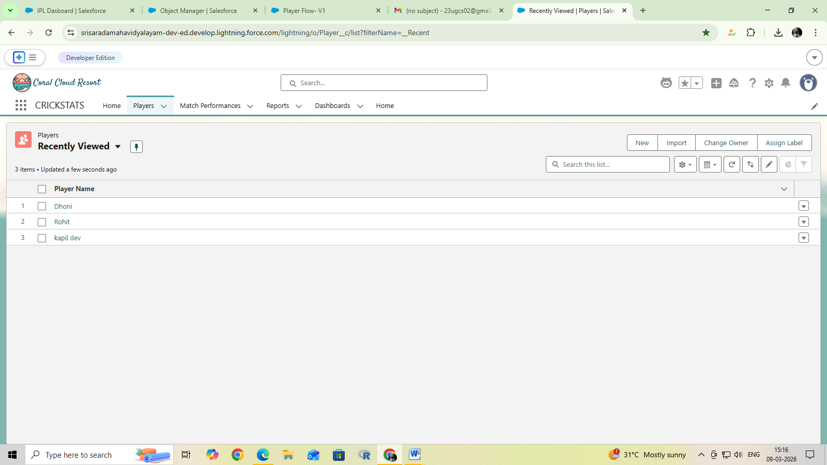

Matches Table
- Match_ID
- Date
- Venue
- Team_A
- Team_B
- 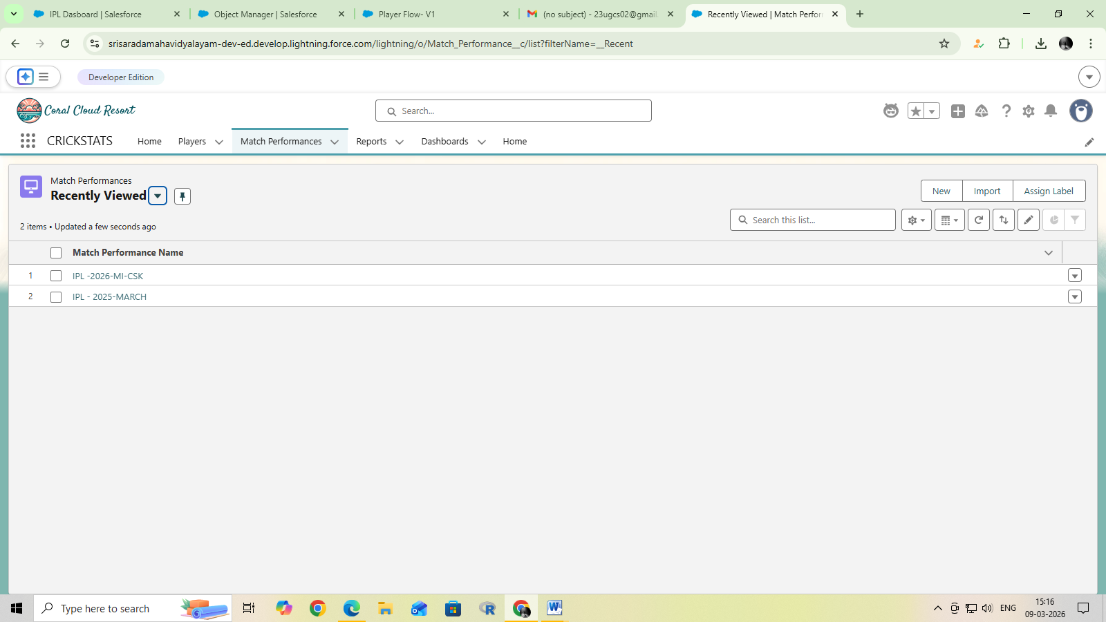

Performance Table
- Performance_ID
- Player_ID
- Match_ID
- Runs
- Balls_Faced
- Wickets
- Overs_Bowled

11. Performance Metrics
The system calculates several important cricket statistics.

Batting Average
Batting Average = Total Runs / Number of Times Out

Strike Rate
Strike Rate = (Runs / Balls Faced) × 100

Bowling Economy Rate
Economy Rate = Runs Conceded / Overs Bowled
These statistics help evaluate player performance accurately.

12. Advantages of the System
The CrickStats application provides several advantages:
- Accurate performance tracking
- Faster data analysis
- Easy access to player statistics
- Improved decision making
- Reduced manual record keeping
- Better performance monitoring

13. Limitations
Although the system provides many benefits, it also has some limitations.
- Requires proper data entry after each match
- Requires basic computer knowledge
- Data security must be maintained properly

14. Future Enhancements
The system can be enhanced with additional features.
Possible improvements include:
- Mobile application for easier access
- Real-time match scoring
- Advanced analytics and graphs
- Player ranking system
- AI-based performance prediction

15. Testing
Testing ensures that the application works correctly.
Types of testing include:
- Unit Testing
- Integration Testing
- System Testing
- User Acceptance Testing

16. Conclusion
The CrickStats – Cricket Player Performance Tracking Application provides an efficient solution for managing cricket statistics and analyzing player performance.
The system simplifies the process of recording match data and calculating performance metrics. It helps coaches and team managers make better decisions based on accurate statistical analysis.
By using this application, cricket teams can improve player development and overall team performance.

17. Literature Review
A literature review helps understand previous research and existing systems related to cricket performance tracking.
Many sports organizations use digital tools to analyze player performance. These systems collect statistical data such as runs scored, wickets taken, strike rate, and batting averages.
Previous studies show that performance analytics plays a significant role in improving team strategies and player development. Advanced analytics tools help coaches analyze player strengths and weaknesses.
However, many small cricket clubs and academies still rely on manual record keeping. These traditional methods make it difficult to track performance across multiple matches.
The CrickStats application aims to address this gap by providing an easy-to-use digital platform for performance tracking and analysis.

18. Methodology
The development of the CrickStats application follows a systematic approach to ensure efficient design and implementation.
The main steps involved in the development process include:

Requirement Analysis
The first step involves identifying the requirements of the system. This includes understanding the needs of coaches, players, and team managers.

System Design
In this stage, the architecture of the system is designed. Database structure, modules, and user interfaces are planned.

Development
The application is developed using programming languages and database technologies.

Testing
Testing is performed to ensure that the system functions correctly and meets the required specifications.

Deployment
The system is deployed and made available for use by the intended users.
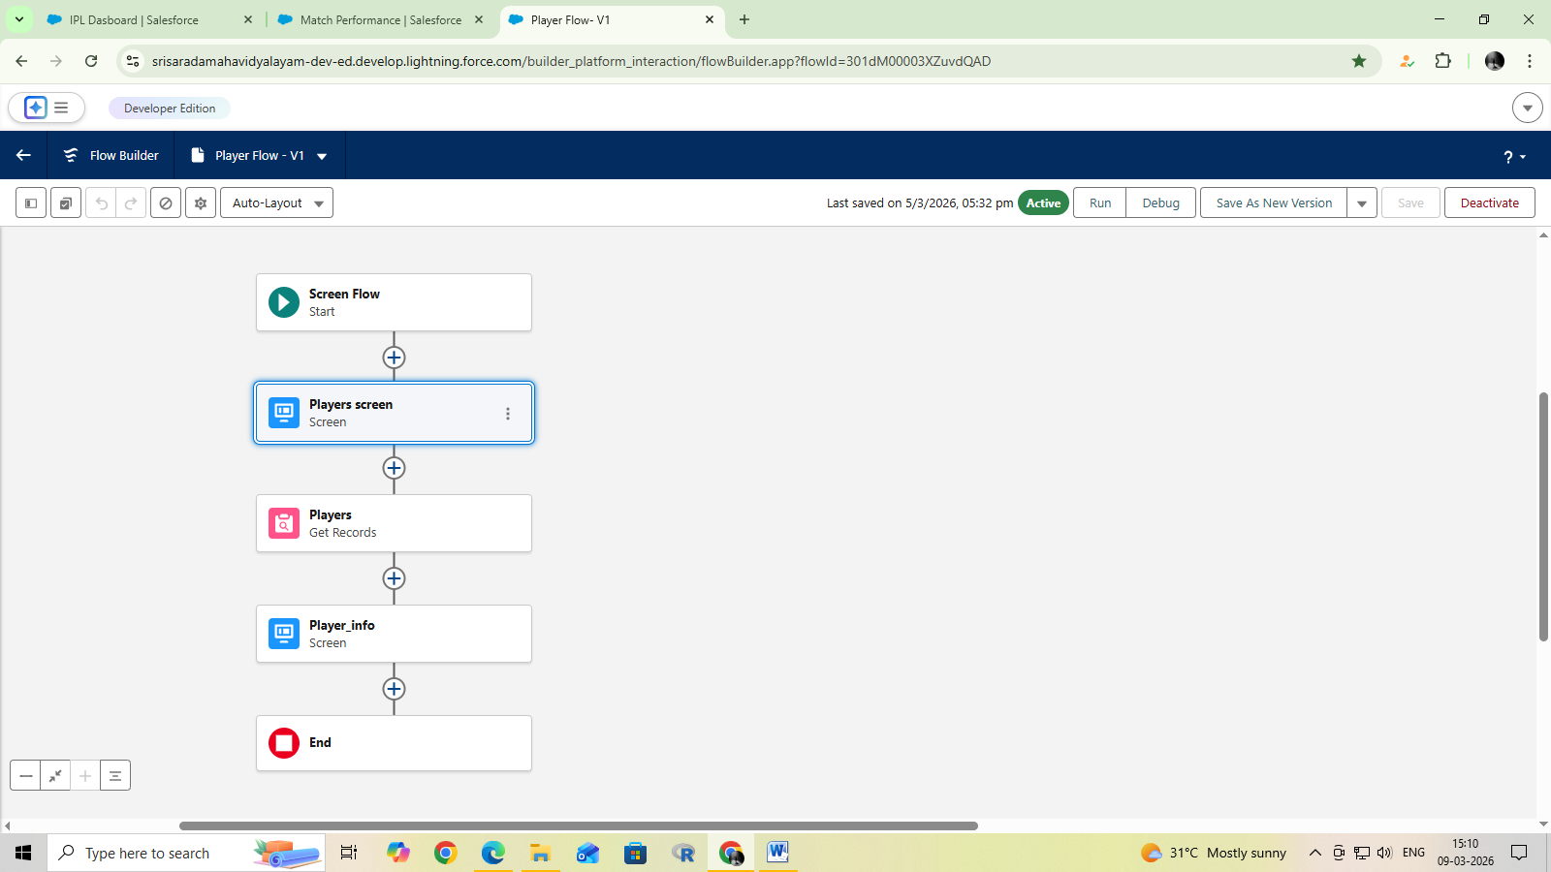

19. Functional Requirements
Functional requirements describe the specific features that the system must perform.
The CrickStats system must support the following functions:
- User login and authentication
- Add and manage player profiles
- Record match details
- Track player performance statistics
- Calculate batting and bowling metrics
- Generate performance reports
- View player statistics history
These functions help ensure that the system effectively tracks and analyses cricket performance data.

20. Non-Functional Requirements
Non-functional requirements describe the quality attributes of the system.

Performance
The system should process data quickly and provide results without delays.

Usability
The user interface should be simple and easy to understand.

Reliability

The system should operate consistently without frequent failures.

Security
The system should protect player data from unauthorized access.

Scalability
The system should be able to handle an increasing number of players and matches.

21. User Roles
The CrickStats system includes different user roles.

Administrator
The administrator manages the entire system. Responsibilities include managing player data, updating match records, and generating reports.

Coach / Team Manager
Coaches can analyze player performance, view statistics, and monitor improvements.

Player
Players can view their personal statistics and performance reports.
Each role has specific permissions to access different features of the system.

22. System Workflow
The system workflow describes the sequence of operations in the CrickStats application.
- The user logs into the system.
- The user selects the module they want to access.
- Player information is entered or updated.
- Match details are recorded.
- Player performance statistics are updated after each match.
- The system automatically calculates performance metrics.
- Reports are generated and displayed to the user.
This workflow ensures efficient management of cricket performance data.

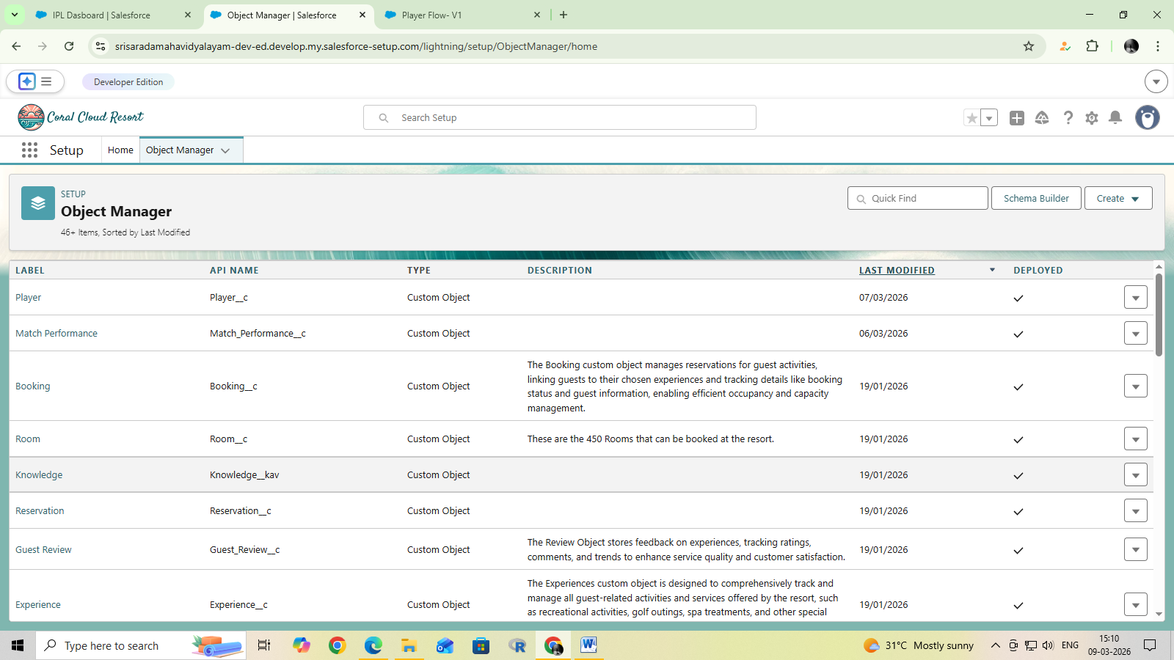

23. Data Collection
Data collection is an important part of the performance tracking system.
The system collects data related to:
- Player personal information
- Match details
- Batting statistics
- Bowling statistics
- Fielding performance
- Match outcomes
Accurate data collection ensures reliable performance analysis.

24. Data Analysis
The CrickStats application analyzes collected data to evaluate player performance.
Data analysis helps identify:
- Top performing players
- Consistent performers
- Areas where players need improvement
- Team performance trends
The analysis helps coaches and team managers make informed decisions about player selection and strategy.

25. Graphical Representation of Statistics
Graphical representations help visualize player performance.
The CrickStats system can generate graphs such as:
- Runs scored per match
- Wickets taken per match
- Batting average over time
- Strike rate trends
Graphs make it easier for coaches and players to understand performance trends.

26. Data Security
Data security is essential for protecting player information.
The system implements security features such as:
- User authentication
- Password protection
- Role-based access control
- Secure database storage
These measures ensure that sensitive data is protected from unauthorized access.

27. Maintenance and Support
After the system is implemented, regular maintenance is required.
Maintenance activities include:
- Fixing bugs and software errors
- Updating system features
- Improving performance
- Ensuring data security
Continuous maintenance ensures that the system remains reliable and efficient.

28. Implementation Plan
The implementation plan outlines how the system will be introduced and used.
Steps include:
- System installation
- Database setup
- User account creation
- Staff training
- Testing and evaluation
- Full system deployment
This structured approach ensures successful implementation.

29. Benefits of the System
The CrickStats application offers several benefits.
- Efficient tracking of player performance
- Accurate calculation of statistics
- Easy access to player data
- Improved decision making for team selection
- Reduced manual work
- Better analysis of player development
These benefits help teams improve their overall performance.

30. Project Summary
The CrickStats – Cricket Player Performance Tracking Application is designed to provide an efficient and reliable system for tracking cricket statistics.
The system allows users to record match details, monitor player performance, and generate analytical reports.
By replacing manual record keeping with a digital system, the application improves accuracy, efficiency, and data analysis.
The project demonstrates how technology can enhance sports performance tracking and support better decision making in cricket teams.

31. System Design
System design is an important phase in software development. It defines the architecture, components, modules, and interfaces of the system.
The design of the CrickStats application focuses on providing an efficient and user-friendly platform for managing cricket performance data. The system is designed to ensure easy data entry, accurate calculation of statistics, and quick access to performance reports.
The system design includes database structure, user interface design, and system architecture. Each component is carefully planned to ensure smooth interaction between different modules.
A well-designed system helps improve efficiency, reduce errors, and enhance the overall performance of the application.

32. Input Design

Input design focuses on how data is entered into the system. Proper input design ensures that the data collected is accurate and complete.
In the CrickStats system, input data includes:
- Player information
- Match details
- Batting statistics
- Bowling statistics
- Fielding performance
The input forms are designed to be simple and user-friendly. Validation checks are implemented to ensure that incorrect or incomplete data is not entered into the system.
For example, numeric fields such as runs, balls faced, and wickets must contain valid numerical values.

33. Output Design
Output design focuses on how information is presented to the user.
The CrickStats application provides several outputs such as:
- Player performance reports
- Match summaries
- Batting statistics
- Bowling statistics
- Team performance analysis
These outputs are presented in a clear and organized format. Tables and charts may be used to improve readability and help users understand performance trends.
Effective output design ensures that users can easily interpret the data generated by the system.

34. System Implementation
System implementation is the stage where the designed system is converted into a working application.
During this stage, the system is developed using programming languages and database technologies. The user interface is created, and database tables are implemented to store player and match information.
Once the development is completed, the system is tested thoroughly to ensure that it functions correctly.
After successful testing, the system is deployed for use by coaches, players, and administrators.

35. System Validation
System validation ensures that the application meets the required specifications and performs as expected.
Validation involves checking whether:
- The system records player statistics correctly
- Calculations such as batting averages and strike rates are accurate
- Reports are generated properly
- The system responds quickly to user inputs
Validation is important to ensure that the application provides reliable performance data.

36. Risk Analysis
Risk analysis helps identify potential problems that may affect the successful operation of the system.
Possible risks include:
- Incorrect data entry
- System failure or technical issues
- Data loss due to hardware failure
- Unauthorized access to sensitive data
These risks can be minimized by implementing proper validation checks, backup systems, and security measures.

37. Ethical Considerations
Ethical considerations are important when handling player data and performance information.
The CrickStats system must ensure that:
- Player data is used responsibly
- Personal information is kept confidential
- Data is not misused for unfair purposes
- Access to sensitive information is restricted
Maintaining ethical standards helps build trust among players and team management.

38. Impact of Technology on Sports Analytics
Technology has significantly transformed the way sports performance is analyzed. Advanced analytics tools are now widely used in professional sports to evaluate player performance and develop game strategies.
In cricket, performance analytics helps coaches analyze batting techniques, bowling patterns, and player consistency.
Applications like CrickStats demonstrate how digital tools can make performance tracking easier and more efficient even for small teams and academies.
Technology also enables data visualization, predictive analysis, and real-time performance monitoring.

39. Comparison with Manual Systems
Manual systems for recording cricket statistics have several disadvantages compared to digital systems.
Manual systems require more time and effort to maintain records. They are also prone to errors and data loss.
Digital systems such as the CrickStats application provide automated calculations and easy access to data. Users can quickly retrieve past records and analyze player performance over multiple matches.
Therefore, digital systems are more efficient, accurate, and reliable compared to manual record keeping.

40. Project Evaluation
Project evaluation helps assess the success of the system after implementation.
The success of the CrickStats application can be evaluated based on the following factors:
- Accuracy of performance statistics
- Ease of use for coaches and players
- Speed of data processing
- Reliability of the system
- Improvement in performance analysis
Positive evaluation results indicate that the system meets its objectives and provides value to users.

41. Final Conclusion
The CrickStats – Cricket Player Performance Tracking Application provides an effective solution for managing and analyzing cricket player statistics.
The system simplifies the process of recording match data and automatically calculates performance metrics such as batting averages, strike rates, and bowling economy rates.
By providing detailed performance reports and analysis, the application helps coaches and team managers make better decisions regarding player development and team selection.
The project demonstrates the importance of digital systems in sports analytics and highlights how technology can improve performance tracking and data management in cricket.
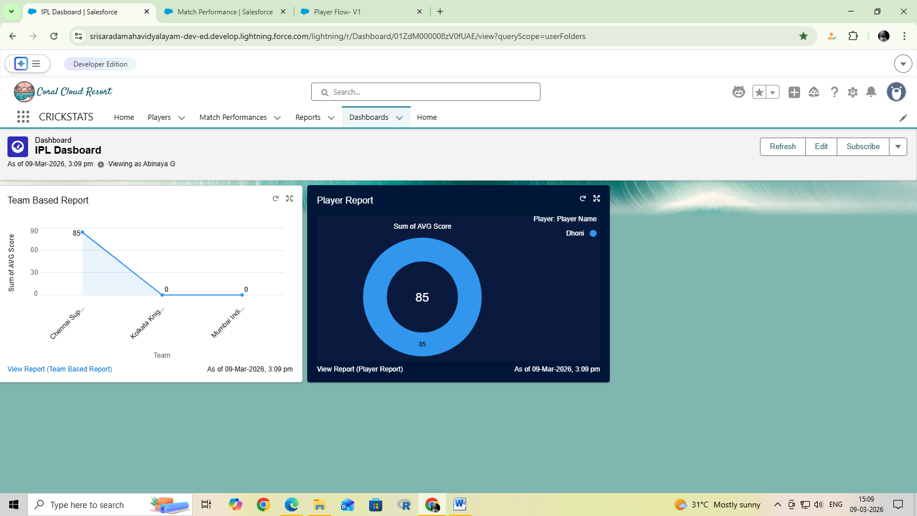

OUTPUT URL:

https://srisaradamahavidyalayam-dev-ed.develop.lightning.force.com/lightning/r/Dashboard/01ZdM000008zV0fUAE/view?queryScope=userFolders

